PRESS & SPEAKING KIT · 2026
RAY
SERGÉY ULYANOV
A queer archive. A second coming-out. A return to music.
Los Angeles · Release: October 11, 2026 · Vinyl only
Press: ulyanoow@gmail.com · nostalgairecordz.com

THE STORY AT A GLANCE

A pop past reclaimed on his own terms
Sergéy Ulyanov is a gay Belarusian artist, actor, activist, and creative strategist rebuilding his life in Los Angeles after exile and U.S. immigration detention—and reclaiming the pop career that once required him to be presented as straight.
“Will this release become my return to music? Of course, that depends on you, too.”
— Sergéy, official RAY release page · translated from Russian

Why now
- Queer culture: an anniversary archive becomes a second coming-out through an old catalog.
- Immigration: legal asylum created safety, but did not automatically restore housing, work, community, or a creative career.
- Belarus and exile: the record preserves songs, voices, and memory across Belarusian, Russian, and English.
- Los Angeles: Sergéy remastered, edited, designed, and self-funded the project while rebuilding locally.
- Human craft in the AI era: an AI-literate creative founder deliberately made this archival release without generative AI.

Release facts
Artist | Sergéy
Title | RAY (10th Anniversary Edition)
Label / catalog | Nostalgai Recordz / NRZ-009
Release date | October 11, 2026 — Sergéy’s birthday and National Coming Out Day
Format | 12-inch black 140g vinyl, 33 RPM; no streaming release
Production | Created in Los Angeles; manufactured in the United Kingdom
Announced run | 350 copies across three sleeve editions
Languages | Belarusian, Russian, and English
New material | Includes ‘I Believe in Me,’ the first English-language demo recorded in the U.S. after four years of silence
Creative process | Mastering, design, editorial concept, and campaign by Sergéy; no generative AI

Career proof points
- The official release page reports 52 concerts, 25 cities, 14 radio singles, six countries, and five music videos across Sergéy’s earlier artist career.
- The Unfiltered Stories video testimony ‘Targeted In His Country For Being Gay’ has reached 79K views as of August 13, 2026.
- Human Rights First published a national profile of his music, activism, displacement, detention, asylum, and rebuilding in June 2026.
- Recent screen work includes appearing as the Husband in Wife Wife, a six-minute queer comedy directed by Sara Werner that premiered at Frameline50 and later screened at OutfestNEXT 2026.
- Sergéy is based in Los Angeles and available for an in-person interview or photo session.
FOR IMMEDIATE RELEASE

Queer Belarusian artist Sergéy reclaims the ‘straight’ pop star he was forced to play on RAY (10th Anniversary Edition)
The Los Angeles-made, vinyl-only archive arrives October 11 with recordings in Belarusian, Russian, and English, unreleased material, and ‘I Believe in Me’—the first new demo from Sergéy’s life in the United States.
LOS ANGELES, August 13, 2026 — Ten years after releasing his first album while the Eastern European music industry presented him as straight, gay Belarusian artist and activist Sergéy Ulyanov is taking ownership of that history with RAY (10th Anniversary Edition), arriving October 11 through his independent imprint Nostalgai Recordz.
The limited physical edition is not a conventional reissue. Remastered, edited, designed, and self-funded by Sergéy in Los Angeles, it combines Belarusian, Russian, and English recordings with unreleased versions, personal archival fragments, mashups, and ‘I Believe in Me,’ the demo of his first new English-language song recorded in the United States after four years of musical silence and adaptation. The project is presented as one continuous vinyl journey assembled by Sergéy under his DJ name, DJ Sir Gay, and will not be released on streaming services.
‘Will this release become my return to music? Of course, that depends on you, too,’ Sergéy writes on the official release page (translated from Russian). The larger act of revisiting the catalog gives the queer person inside that old public image the authorship he was denied and asks whether returning to an old voice can become a second coming-out.
Sergéy built an independent pop career across Eastern Europe while maintaining a separate life as an LGBTQ+ activist. During Belarus’s 2020 democratic uprising, he released political music and saw his website blocked. He later left Belarus for Ukraine, fled again after Russia’s full-scale invasion, and reached the United States in 2022. After nearly a month in immigration detention, he received asylum in 2024 and began rebuilding his life and multidisciplinary career in Los Angeles.
Human Rights First recently profiled how music carried Sergéy through bullying, concealment, protest, displacement, detention, and the difficult period after receiving legal protection. His filmed testimony, ‘Targeted In His Country For Being Gay,’ has reached 79K views on Unfiltered Stories as of August 13, 2026, offering a direct visual account of the journey behind the new record. The anniversary release extends that story through the surviving recordings themselves.
Created in Los Angeles and manufactured in the United Kingdom, RAY (10th Anniversary Edition) will be pressed on 12-inch black 140g vinyl at 33 RPM in three distinct sleeves: Ocean Grey Original (200 copies), Dreamwash Blue Deluxe (100 copies), and Candy Melt Pink Collector (50 individually numbered copies). The combined announced run is 350 copies.
Sergéy created the mastering, design, editorial concept, and campaign without generative AI. That decision is intentional: although his professional work includes AI-enabled creative production, this release treats human memory, imperfection, and physical authorship as part of the artifact.
RAY (10th Anniversary Edition) arrives October 11, Sergéy’s birthday and National Coming Out Day.

Links
Release information — Open source
Human Rights First background profile — Open source
Watch — Targeted In His Country For Being Gay (79K views) — Open source
Private editorial audio: ‘I Believe in Me’ is available to music and radio editors on request; the preview link is intentionally omitted from the public release.
FAST EDITORIAL COPY

Short release
Gay Belarusian artist and activist Sergéy will release RAY (10th Anniversary Edition) on October 11 through Nostalgai Recordz. The Los Angeles-made, vinyl-only archive revisits the album he created while the Eastern European music industry publicly presented him as straight. Remastered, edited, designed, and self-funded by Sergéy, it combines Belarusian, Russian, and English recordings with unreleased versions, personal fragments, and ‘I Believe in Me,’ his first new English-language demo after four years of displacement and creative silence. The three editions total 350 copies and will not be released on streaming services. After fleeing Belarus and the war in Ukraine, experiencing U.S. immigration detention, and receiving asylum in 2024, Sergéy now frames the record as both a return to music and a second coming-out through his own archive. His filmed testimony, ‘Targeted In His Country For Being Gay,’ has reached 79K views on Unfiltered Stories.

Alternate headlines
- Can a Reissue Become a Second Coming-Out? Sergéy Reclaims RAY Ten Years Later
- After Exile and Asylum, a Gay Belarusian Pop Artist Returns to the Album That Hid Him
- A Queer Archive on Vinyl: Sergéy Preserves Belarusian Memory Across Three Languages
- No Streaming, No Generative AI: Sergéy Turns a Straight-Washed Pop Past into a Physical Queer Archive
INTERVIEW PREPARATION

Interview prompts
- What did the music industry require you to hide, and how did that affect the work itself?
- When you reopened the archive ten years later, what surprised or hurt you most?
- Why make a physical record instead of returning through streaming?
- What changed after asylum—and what did not?
- Why was it important to make this project without generative AI even though you work with AI professionally?
- Does RAY feel like an artifact from a former life or the beginning of a new one?

Messaging anchors
- RAY is not a nostalgia project; it is an act of authorship over a public identity that once excluded Sergéy’s queerness.
- Asylum ended an immediate legal danger, but rebuilding housing, work, health, community, and a creative future remained a separate process.
- The multilingual archive preserves Belarusian cultural memory while allowing the artist to move toward English-language work in the United States.
- The no-generative-AI choice is not anti-technology; it protects consent, imperfection, memory, and human authorship in this particular artifact.
- The creative work leads the story. Displacement and trauma provide context and stakes, not Sergéy’s entire identity.

Bios

50 words
Sergéy Ulyanov is a gay Belarusian artist, actor, activist, and creative strategist based in Los Angeles. After exile, U.S. immigration detention, and asylum, he founded Nostalgai Recordz and began rebuilding a multidisciplinary career. His work connects queer identity, Belarusian cultural memory, migration, music, film, and human-centered creative technology.

100 words
Sergéy Ulyanov is a gay Belarusian artist, actor, LGBTQ+ advocate, and creative strategist based in Los Angeles. He built an Eastern European pop career while the industry publicly presented him as straight, then used music and activism during Belarus’s democratic uprising. After leaving Belarus, fleeing the war in Ukraine, spending nearly a month in U.S. immigration detention, and receiving asylum in 2024, he began rebuilding across music, film, marketing, and technology. Through Nostalgai Recordz, an independent imprint centered on artists and cultural memory in exile, Sergéy creates physical releases that connect queer identity, migration, and human authorship.

250 words
Sergéy Ulyanov is a gay Belarusian artist, actor, activist, and creative strategist whose work sits at the intersection of queer identity, migration, cultural memory, and technology. He began his public career as a pop singer in Eastern Europe, earning radio play, performing internationally, and taking part in Belarus’s Eurovision selection ecosystem. During part of that career, the music industry presented him as straight even as he spent years advocating for LGBTQ+ people.
In 2020, Sergéy used music in support of Belarus’s democratic movement and saw his website blocked. He later left Belarus for Ukraine, fled again after Russia’s full-scale invasion, and reached the United States in 2022. He spent nearly a month in immigration detention before beginning the asylum process and received asylum in 2024.
Now based in Los Angeles, Sergéy works across music, acting, creative production, brand strategy, and AI-enabled workflows. He appeared as the Husband in Wife Wife, a six-minute queer comedy directed by Sara Werner that premiered at Frameline50 and later screened at OutfestNEXT 2026. Human Rights First profiled his journey in ‘Never Lose Yourself: How Music Helped Sergey Reclaim His Future.’
Sergéy founded Nostalgai Recordz to preserve music and memory connected to artists in exile. His 2026 release, RAY (10th Anniversary Edition), revisits the album he made while publicly straight-washed and reframes it as a queer, multilingual physical archive. He personally remastered, edited, designed, and self-funded the vinyl-only edition in Los Angeles without generative AI.
SCREEN STORY

The day I got married on camera
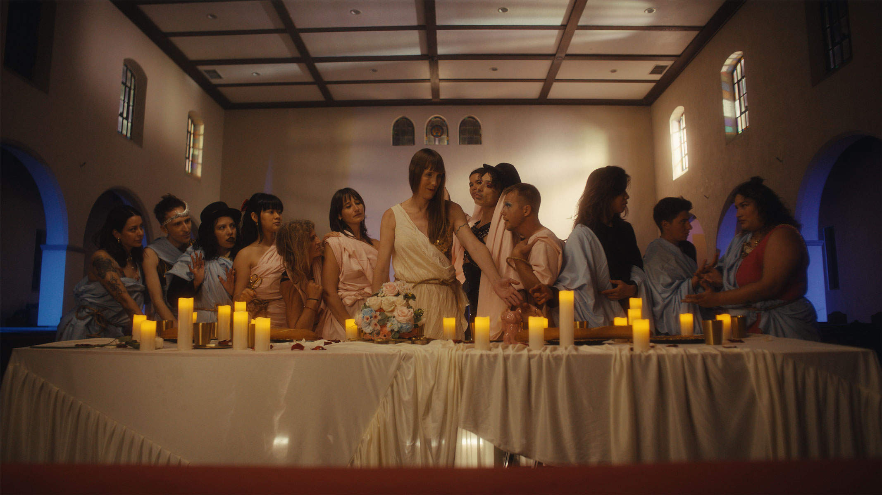
Sergéy Ulyanov (right of center) as the Husband in Wife Wife. Film still from the church sequence.
Credit: Husband · Writer/director: Sara Werner · USA · English · 6 minutes
Festival path: Frameline50 world premiere in San Francisco; OutfestNEXT 2026 screening in Los Angeles.
“I definitely did not wake up that morning thinking I would end the day getting married in a church on camera — in a wedding dress, with flowers, makeup, an amazing group of queer people, and lots and lots of love. It was hilarious. It was unexpected. And it was also deeply personal.”
SERGÉY ULYANOV

I come from Belarus, where queer visibility can still be dangerous. For people with stories like mine, visibility is not just a Pride Month slogan. It can be a risk. It can be a survival strategy. It can also be a way of choosing life after years of being told to disappear.
For a gay Belarusian artist who was once required to perform heterosexuality in public, the comedy became more than a festival credit: it offered a playful image of what his own future wedding with a husband might one day look like. Who knows. Maybe one day.
Festival record: Frameline50 · OutfestNEXT 2026 · Watch the 79K-view video story
STORY ARCHITECTURE

Editorial angles
Angle | Core question | Best format
The straight pop star I had to play | What does commercial straight-washing do to a queer artist? | Profile or first-person essay
Wife Wife: married on camera | What happens when a gay refugee gets to rehearse a joyful queer future in a church comedy? | Profile, interview, or photo essay
After asylum | Why does legal safety fail to restore housing, work, health, and belonging? | Reported essay, interview, or panel
The record as a second coming-out | Can an archival reissue repair a divided public identity? | Culture essay, profile, or podcast
Queer Belarusian memory | What survives when artists carry songs and language into exile? | International feature or radio segment
Human craft in the AI era | Why would an AI-literate founder deliberately make an album without generative AI? | Interview or op-ed
Vinyl outside streaming | Can a 350-copy object be more culturally meaningful than an algorithmic release? | Music-business or process feature

Selected coverage
Human Rights First — Never Lose Yourself: How Music Helped Sergey Reclaim His Future — Open source
Frameline50 — Wife Wife — Open source
KYKY — actor and coming-out profile — Open source
Unfiltered Stories — Targeted In His Country For Being Gay (79K views as of Aug. 13, 2026) — Open source
Nasha Niva — Belarusian actor building a career in the United States — Open source
Zerkalo — asylum and viral music story — Open source
SOTAvision — LGBTQ+ acceptance, music, and activism — Open source
ForumDaily — fleeing homophobia and reaching the United States — Open source
SPEAKING PLATFORM

From lived experience to actionable systems
Sergéy is strongest when positioned not only as a refugee speaker, but as a practitioner connecting lived experience with practical systems: queer safety, community belonging, creative leadership, cultural preservation, and human-centered technology.

Signature topics
- After Asylum: Why Legal Safety Is Not the Finish Line
- The Straight Pop Star I Had to Play
- Human Connection Is Infrastructure: Rebuilding Across Exile, Queerness, and AI
- Music as Evidence, Memory, and Home
- Leading Without a Map: What Displacement Teaches About Adaptive Creative Work

Featured workshop

After Asylum: Building Queer Safety Beyond Legal Status
Winning asylum is often narrated as the end of a queer refugee story. In practice, legal protection may arrive long before stable housing, work, health care, community, or a restored sense of future. Drawing on Sergéy’s experience as a gay Belarusian activist, artist, former immigration detainee, and creative professional rebuilding in Los Angeles, this interactive workshop gives participants a practical framework for understanding safety beyond paperwork. Participants map the legal, economic, social, cultural, and psychological layers of queer safety; identify where their organizations unintentionally stop at status; and design one support intervention that protects agency rather than turning lived experience into a trauma performance.

Learning outcomes
- Distinguish legal protection from durable queer safety.
- Identify at least three post-status gaps in organizational support systems.
- Design one agency-preserving practice for storytelling, employment, housing, or community integration.

Speaker bio
Sergéy Ulyanov is a gay Belarusian artist, activist, creative strategist, and founder based in Los Angeles. He built a public pop career while being marketed as straight, organized for LGBTQ+ visibility, created political music during Belarus’s democratic uprising, and rebuilt after exile, war, U.S. immigration detention, and asylum. Today he works across music, film, brand strategy, and AI-enabled creative production. His talks translate lived experience into practical frameworks for human-centered leadership, cultural preservation, queer safety, and rebuilding systems that do not require people to erase themselves in order to belong.

Additional leadership session

Human Connection Is Infrastructure When the Org Chart Wasn’t Built for You
What happens when a leader must rebuild without inherited networks, familiar language, stable status, or an institution designed to recognize their experience? Sergéy connects queer exile, creative entrepreneurship, marketing leadership, and AI-enabled work to show that human connection is not a soft benefit—it is operating infrastructure. Participants examine how identity pressure distorts decisions at the self level, how organizations confuse assimilation with adaptability at the systems level, and how reciprocal networks create resilience at the community level.

Participant takeaways
- Identify where a team currently rewards concealment or assimilation.
- Map missing relationship infrastructure around one high-stakes goal.
- Choose one measurable 30-day leadership practice that increases trust and access.
PRESS RESOURCES

Available on request
- Interview in English, Russian, Belarusian, or Ukrainian, with preparation time as needed
- High-resolution portraits and Los Angeles photography
- Wife Wife poster, festival links, and five approved film/BTS stills from the church sequence
- Artwork and product images for all three vinyl editions
- Public proof video: Targeted In His Country For Being Gay — 79K views as of August 13, 2026
- Private editorial preview of ‘I Believe in Me’ for named music/radio recipients; not for publication or redistribution
- Earlier music videos, performance footage, and broadcast clips
- A documented press timeline covering music, LGBTQ+ activism, migration, acting, and creative work
- In-person interview or photo session in Los Angeles

Press contact
Name | Sergéy Ulyanov
Location | Los Angeles, California
Email | ulyanoow@gmail.com
Label | Nostalgai Recordz
Website | https://www.nostalgairecordz.com
Release page | https://www.nostalgairecordz.com/releases/ray-candy-melt-pink

“The 2026 story is creative work first. The life story provides depth, authority, and stakes.”
PRESS POSITIONING

